**Technical Assignment for NestJS Backend Developer Position at Dinamo MEA  
  
Mohamed Amir**[**mohamedamirr424@gmail.com**](mailto:mohamedamirr424@gmail.com) **01001733917**

**Overview**

This document outlines the technical assignment for developing a backend application using **NestJS** and **MongoDB**. The focus is on designing a database schema for core entities, implementing the schemas/models in a NestJS application, and proposing an authentication strategy.

**Objectives**

1. Design a Database Schema for the core entities:
   * Product
   * Vendor
   * User
   * Cart
2. Create a NestJS Application:
   * Set up a basic NestJS app.
   * Implement the schemas/models for the core entities.
3. List REST Endpoints:
   * Provide a list of RESTful API endpoints that would interact with these entities.
4. Propose an Authentication Solution suitable for serving multiple applications and user types.

**Core Entities**

The core entities for the application are as follows:

1. **User**
   * Represents application users, including their roles (admin, vendor, customer).
2. **Vendor**
   * Represents vendors who sell products in the application.
3. **Product**
   * Represents products available for purchase.
4. **Cart**
   * Represents the shopping cart functionality for users.

**Extra Modules**

In addition to core entities, extra modules can enhance the application:

1. **Order**
   * Represents user orders.
2. **Wishlist**
   * Represents user wishlists for saving favorite products.
3. **Review**
   * Represents product reviews written by users.

**Entity Relationship Diagram (ERD)**

The database schema design is based on the core entities and their relationships as outlined in the ERD. The schema is defined in Mongoose models and will include:

* **User Model**: Contains user attributes and relationships to cart, wishlist, and orders.
* **Vendor Model**: Contains vendor attributes and relationships to products.
* **Product Model**: Contains product attributes and relationships to vendor, cart, and reviews.
* **Cart Model**: Contains cart attributes and relationships to user and products.
* **Order Model**: Contains order attributes and relationships to user and products.
* **Wishlist Model**: Contains wishlist attributes and relationships to user and products.
* **Review Model**: Contains review attributes and relationships to user and product.

1. **User Entity**:
   * **Attributes**:
     + _id: ObjectID (Primary Key)
     + name: String
     + email: String (Unique)
     + password: String (Hashed for security)
     + role: String (e.g., customer, admin, vendor)
     + cart: Cart (One-to-One relation)
     + wishlist: [Product] (Many-to-Many relation)
     + orders: [Order] (One-to-Many relation)
   * **Relationships**:
     + Each user can have one cart.
     + Each user can have many orders.
     + Each user can have many products in their wishlist.
2. **Vendor Entity**:
   * **Attributes**:
     + _id: ObjectID (Primary Key)
     + name: String
     + email: String (Unique)
     + products: [Product] (One-to-Many relation)
   * **Relationships**:
     + Each vendor can list many products.
3. **Product Entity**:
   * **Attributes**:
     + _id: ObjectID (Primary Key)
     + name: String
     + price: Number
     + description: String
     + category: String
     + vendor: Vendor (Many-to-One relation)
     + stock: Number (Optional, for inventory management)
     + ratings: [Review] (One-to-Many relation)
   * **Relationships**:
     + Each product belongs to a vendor.
     + Each product can have many ratings (if the review module is included).
     + Each product can appear in many carts and wishlists.
4. **Cart Entity**:
   * **Attributes**:
     + _id: ObjectID (Primary Key)
     + user: User (One-to-One relation)
     + items: [{ product: Product, quantity: Number }] (Many-to-Many relation with products)
     + totalPrice: Number (Calculated field)
   * **Relationships**:
     + A cart belongs to one user.
     + A cart contains many products.
5. **Order Entity** (Extra Module):
   * **Attributes**:
     + _id: ObjectID (Primary Key)
     + user: User (Many-to-One relation)
     + products: [{ product: Product, quantity: Number }]
     + totalPrice: Number (Calculated field)
     + status: String (e.g., pending, completed, shipped)
     + createdAt: Date
   * **Relationships**:
     + An order belongs to one user.
     + An order contains many products.
6. **Wishlist Entity** (Extra Module):
   * **Attributes**:
     + _id: ObjectID (Primary Key)
     + user: User (One-to-One relation)
     + products: [Product] (Many-to-Many relation)
   * **Relationships**:
     + Each user can have a wishlist containing many products.
7. **Review Entity** (Extra Module):
   * **Attributes**:
     + _id: ObjectID (Primary Key)
     + user: User (Many-to-One relation)
     + product: Product (Many-to-One relation)
     + rating: Number
     + comment: String
   * **Relationships**:
     + Each review is linked to a user and a product.

**Relationships Summary:**

* **User ↔ Cart**: One-to-One (Each user has one cart).
* **User ↔ Order**: One-to-Many (Each user can have multiple orders).
* **User ↔ Wishlist**: One-to-One (Each user has one wishlist containing many products).
* **Vendor ↔ Product**: One-to-Many (Each vendor can list many products).
* **Product ↔ Cart**: Many-to-Many (Products can be added to many carts).
* **Product ↔ Wishlist**: Many-to-Many (Products can be added to many wishlists).
* **Product ↔ Review**: One-to-Many (A product can have many reviews).
* **User ↔ Review**: One-to-Many (A user can write many reviews).

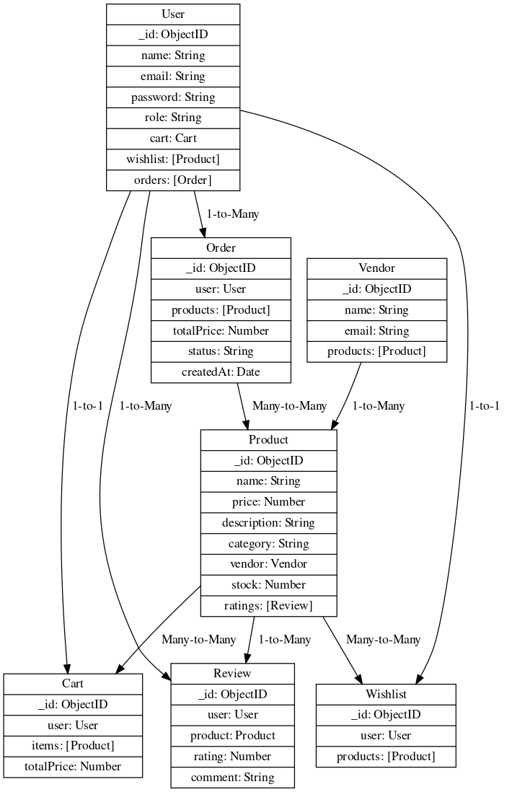

**RESTful API Endpoints**

**User Endpoints**

* POST /users: Register a new user.
* GET /users/:id: Retrieve user details.
* PUT /users/:id: Update user details.
* DELETE /users/:id: Delete a user.

**Vendor Endpoints**

* POST /vendors: Create a new vendor.
* GET /vendors/:id: Retrieve vendor details.
* GET /vendors: Retrieve all vendors.

**Product Endpoints**

* POST /products: Create a new product.
* GET /products/:id: Retrieve product details.
* GET /products: Retrieve all products.
* PUT /products/:id: Update product details.
* DELETE /products/:id: Delete a product.

**Cart Endpoints**

* GET /carts/:userId: Retrieve the user's cart.
* POST /carts: Add product to cart.
* PUT /carts/:userId: Update cart items.
* DELETE /carts/:userId: Clear the cart.

**Order Endpoints (Extra)**

* POST /orders: Create a new order.
* GET /orders/:userId: Retrieve user orders.

**Wishlist Endpoints (Extra)**

* GET /wishlists/:userId: Retrieve user's wishlist.
* POST /wishlists: Add product to wishlist.
* DELETE /wishlists/:userId: Clear wishlist.

**Review Endpoints (Extra)**

* POST /reviews: Add a review for a product.
* GET /reviews/:productId: Retrieve all reviews for a product.

|  |  |  |
| --- | --- | --- |
| Method | Endpoint | Description |
| POST | /users | Register a new user. |
| GET | /users/:id | Retrieve user details. |
| PUT | /users/:id | Update user details. |
| DELETE | /users/:id | Delete a user. |
| POST | /vendors | Create a new vendor. |
| GET | /vendors/:id | Retrieve vendor details. |
| GET | /vendors | Retrieve all vendors. |
| POST | /products | Create a new product. |
| GET | /products/:id | Retrieve product details. |
| GET | /products | Retrieve all products. |
| PUT | /products/:id | Update product details. |
| DELETE | /products/:id | Delete a product. |
| GET | /carts/:userId | Retrieve the user's cart. |
| POST | /carts | Add product to cart. |
| PUT | /carts/:userId | Update cart items. |
| DELETE | /carts/:userId | Clear the cart. |
| POST | /orders | Create a new order. |
| GET | /orders/:userId | Retrieve user orders. |
| GET | /wishlists/:userId | Retrieve user's wishlist. |
| POST | /wishlists | Add product to wishlist. |
| DELETE | /wishlists/:userId | Clear wishlist. |
| POST | /reviews | Add a review for a product. |
| GET | /reviews/:productId | Retrieve all reviews for a product. |

**Authentication Strategy**

**Overview**

The authentication strategy will ensure secure access to the API for different user types (customers, vendors, and admins). The following approach will be implemented:

1. **User Registration**: Users will register by providing their email and password. Passwords will be hashed using bcrypt before being stored in the database.
2. **User Login**: Users will log in with their email and password. Upon successful login, a JSON Web Token (JWT) will be issued.
3. **Token-Based Authentication**:
   * JWTs will be used to authenticate requests to protected routes.
   * Each request to a protected endpoint must include the JWT in the Authorization header.
4. **Authorization Middleware**: Middleware will check the validity of the JWT and ensure that the user has the required permissions to access specific resources.
5. **Role-Based Access Control (RBAC)**:
   * Different roles (admin, vendor, customer) will have different permissions.
   * Admins will have full access, vendors will manage their products, and customers will be able to view and purchase products.

**Development Instructions**

1. **Set Up NestJS Application**: Initialize a new NestJS project using the CLI.

nest new dinamo

cd dinamo

1. **Install Required Packages**: Install Mongoose and other necessary dependencies.

npm install @nestjs/mongoose mongoose bcrypt jsonwebtoken @nestjs/passport passport passport-jwt

1. **Create Mongoose Models**: Implement the defined schemas for core entities and extra modules.
2. **Implement REST API Endpoints**: Create controllers and services for each entity and implement the defined API endpoints.
3. **Implement Authentication**: Set up authentication using JWT, including registration, login, and middleware.

**Testing**

* Use Jest for unit testing of all functions and API endpoints.
* Ensure all endpoints are thoroughly tested, including positive and negative test cases.